**Can’t Build Game**

Project Sun Cycle - Germain Spriet

Problem

When trying to build your Unity Project into a standalone executable game that can be run you get an error message that says “Cannot build player while editor is importing assets or compiling scripts.”

Example

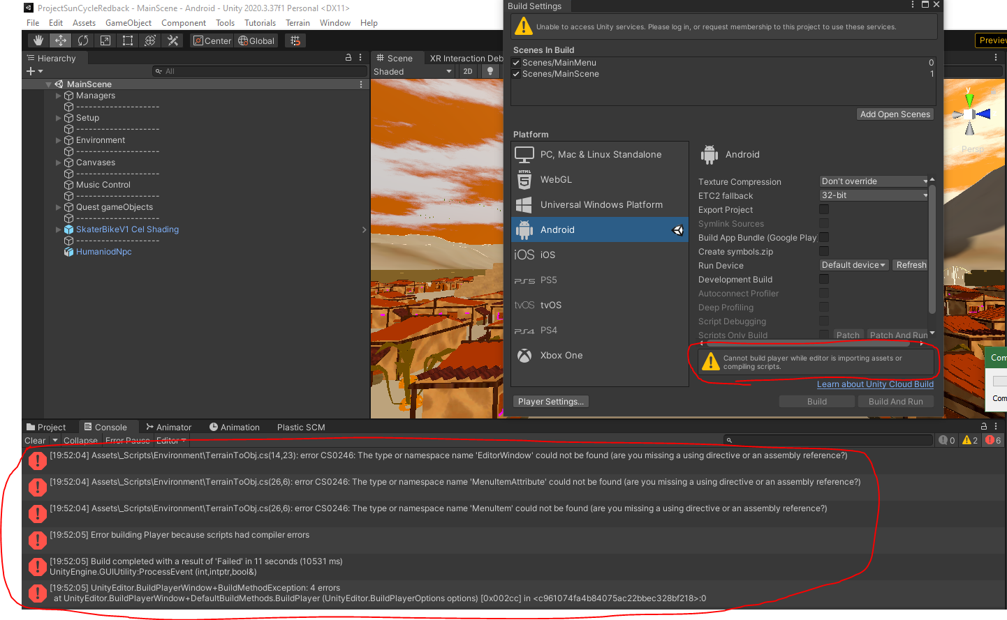Solution

In this case the problem is that there is a script (TerrainToObj) within the project assets which is importing the “using UnityEditor” library to use for certain functionality. These types of scripts which are meant to work in the unity editor are not mean to be used in the built game, which is why we are getting the error.  
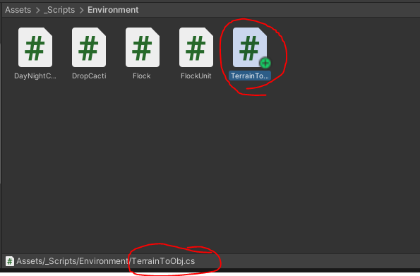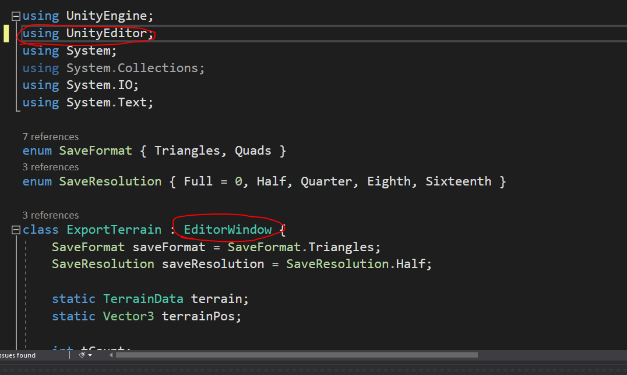

An easy way to solve this issue is to create a “Special Folder” called **Editor** that contains any scripts which use the “using UnityEditor” namespace, this then tells Unity to exclude scripts in this folder when building the game.

Special Folders: <https://docs.unity3d.com/Manual/SpecialFolders.html>

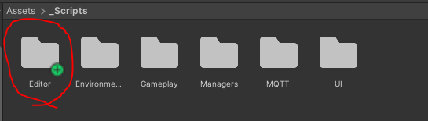

Other solutions

Another possible solution to this is problem is to go into the script that is using the UnityEditor namespace and use conditional compilation to only run certain parts of the script if it is in the editor mode.

Conditional compilation: <https://docs.unity3d.com/Manual/PlatformDependentCompilation.html>

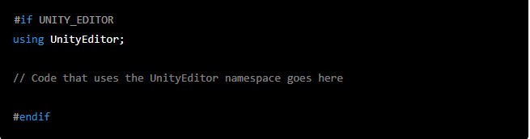

If all else fails then you can always just move out the error giving scripts from the project directory and then once the game has been built you can move them back into the project directory.